**Ambulance service**

**To do**

Web app for coordinating the work of the ambulance service.

Application should do:

* Display and edit list of crews;
* Display and edit list of cars;
* Display and edit list of call;
* View the total number of calls for each of the crews and filter calls by date.

**1. Crews**

**1.1 Display list of crews**

The mode is designed to view the list of crews, as well as the number of calls for each of the crews, it is possible to display the number of calls for a specified period of time.

***Main scenario:***

* User selects item “Crews”;
* Application displays list of Crews.

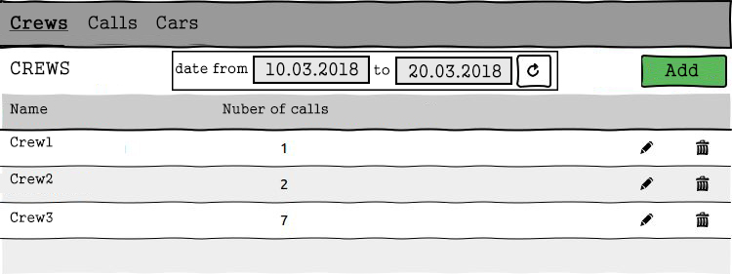

Pic. 1.1 View the Crews list.

The list displays the following columns:

* Name – name of the crew;
* Number of calls – number of calls.

***Filtering by date:***

* In the crew list view mode, the user sets a date filter and presses the refresh list button (to the right of the date entry field);
* The application will display a form to view the list of crews with updated data, the number of calls specified for the desired period of time.

**1.2 Add crew**

***Main scenario:***

* User clicks the “Add” button in the crew list view mode;
* Application displays form to enter crew data;
* User enters crew data and presses “Save” button;
* If any data is entered incorrectly, incorrect data messages are displayed;
* If entered data is valid, then record is adding to database;
* If error occurs, then error message is displaying;
* If new crew record is successfully added, then list of crews with added records is displaying.

***Cancel operation scenario:***

* User clicks the “Add” button in the crew list view mode;
* Application displays form to enter crew data;
* User enters crew data and presses “Cancel” button;
* Data don’t save in data base, then list of crews records is displaying to user.
* If the user selects the menu item "Crews”, ”Calls” or "Cars", the data will not be saved to the database and the corresponding form with updated data will be opened.

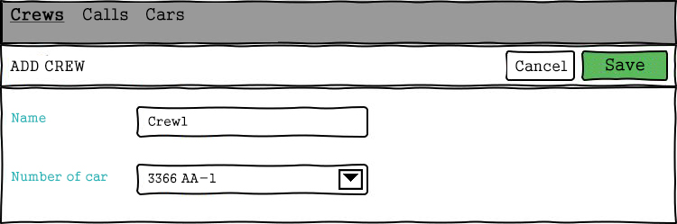

Pic. 1.2 Add crew.

When adding a crew, the following details are entered:

* Name – name of the crew;
* Number of car – registration plate of the car assigned to the crew.

**1.3 Edit crew.**

***Main scenario:***

* User clicks the “Edit” button in the crew list view mode;
* Application displays form to enter crew data;
* User enters crew data and presses “Save” button;
* If any data is entered incorrectly, incorrect data messages are displayed;
* If entered data is valid, then edited data is added to database;
* If error occurs, then error message is displaying;
* If crew record is successfully edited, then list of crews with added records is displaying.

***Cancel operation scenario:***

* User clicks the “Edit” button in the crew list view mode;
* Application displays form to enter crew data;
* User enters crew data and presses “Cancel” button;
* Data don’t save in data base, then list of crews records is displaying to user.
* If the user selects the menu item "Crews”, ”Calls” or "Cars", the data will not be saved to the database and the corresponding form with updated data will be opened.

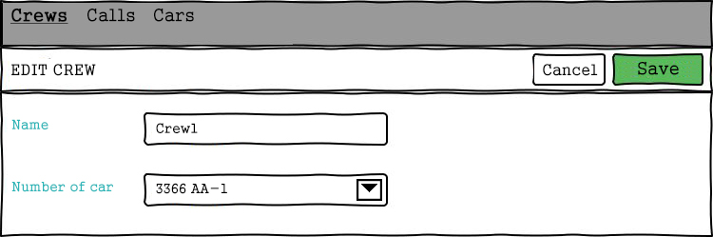

Pic. 1.3 Edit crew.

When editing a crew, the following details are entered:

* Name – name of the crew;
* Number of car – registration plate of the car assigned to the crew.

Constraints for data validation:

* Name – maximum length of 30 characters. The value must be unique in the database.

**1.4 Removing the crew**

***Main scenario:***

* The user, while in the list of crews mode, presses the "Delete" button in the selected crew line;
* If the crew has any calls, the application displays a message that the crew can not be removed.
* If the crew can be removed, a confirmation dialog is displayed;
* The user confirms the removal of the crew;
* Record is deleted from database;
* If error occurs, then error message displays;
* If crew record is successfully deleted, then list of crews without deleted records is displaying.

***Cancel operation scenario:***

* User is in display mode of crews list and press “Delete” button;
* Application displays confirmation dialog “Please confirm delete crew?”;
* User press “Cancel” button;
* List of crews without changes is displaying.

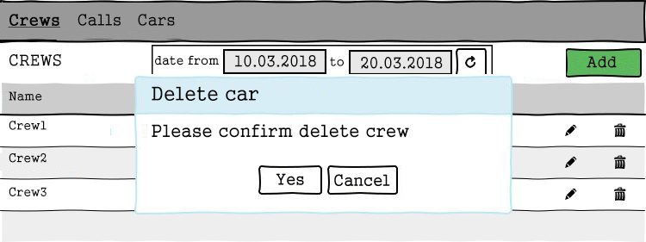

Pic. 1.4 Delete crew dialog.

**2. Calls**

**2.1 Display list of calls**

This mode is intended for viewing and editing the calls list.

***Main scenario:***

* User selects item “Calls”;
* Application displays list of calls.

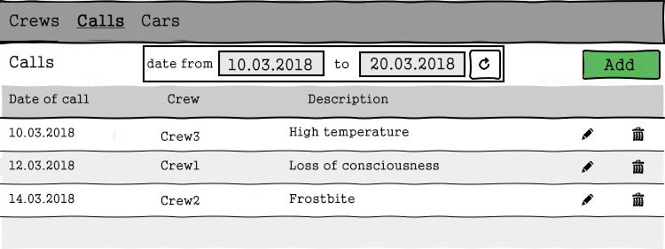

Pic 2.1 View the calls list.

The list displays the following columns:

* Date of call – name of the crew;
* Crew – name of the crew.
* Description - description of the call

***Filtering by date:***

* In the calls list view mode, the user sets a date filter and presses the refresh list button (to the right of the date entry field);
* The application will show the calls only for a certain period of time.

Restrictions:

* Start date of the period should be less then end date of the period;
* If start date is blank, then filtering by end date only.
* If end date is blank, then filtering by start date only.
* Updating data after selecting the filtering conditions is carried out by pressing the “Refresh” button.

**2.2 Add call**

***Main scenario:***

* User clicks the “Add” button in the calls list view mode;
* Application displays form to enter call data;
* User enters call data and presses “Save” button;
* If any data is entered incorrectly, incorrect data messages are displayed;
* If entered data is valid, then record is adding to database;
* If error occurs, then error message is displaying;
* If new crew record is successfully added, then list of calls with added records is displaying.

***Cancel operation scenario:***

* User clicks the “Add” button in the calls list view mode;
* Application displays form to enter call data;
* User enters call data and presses “Cancel” button;
* Data don’t save in data base, then list of calls records is displaying to user.
* If the user selects the menu item "Crews”, ”Calls” or "Cars", the data will not be saved to the database and the corresponding form with updated data will be opened.

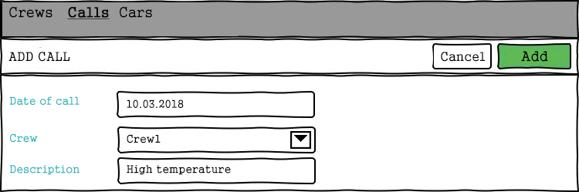

Pic. 2.2 Add call.

When adding a call, the following details are entered:

* Date of call – date of call;
* Crew – name of the crew;
* Description - description of the call.

Restrictions:

* Date of call – system date;
* Crew – value from the list of available crews;
* Description – optional field, up to 255 characters.

**2.3 Edit call**

***Main scenario:***

* User clicks the “Edit” button in the calls list view mode;
* Application displays form to enter call data;
* User enters call data and presses “Save” button;
* If any data is entered incorrectly, incorrect data messages are displayed;
* If entered data is valid, then edited data is added to database;
* If error occurs, then error message is displaying;
* If call record is successfully edited, then list of calls with added records is displaying.

***Cancel operation scenario:***

* User clicks the “Edit” button in the calls list view mode;
* Application displays form to enter call data;
* User enters call data and presses “Cancel” button;
* Data don’t save in data base, then list of calls records is displaying to user.
* If the user selects the menu item "Crews”, ”Calls” or "Cars", the data will not be saved to the database and the corresponding form with updated data will be opened.

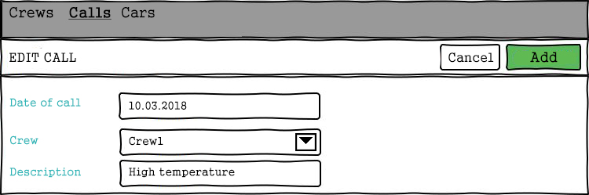

Рис. 2.3 Edit call

**2.4 Removing the call**

***Main scenario:***

* The user, while in the list of calls mode, presses the "Delete" button in the selected call line;
* Application displays confirmation dialog “Please confirm delete call?”;
* The user confirms the removal of the call;
* Record is deleted from database;
* If error occurs, then error message displays;
* If call record is successfully deleted, then list of calls without deleted records is displaying.

***Cancel operation scenario:***

* User is in display mode of calls list and press “Delete” button;
* Application displays confirmation dialog “Please confirm delete call?”;
* User press “Cancel” button;
* List of calls without changes is displaying.

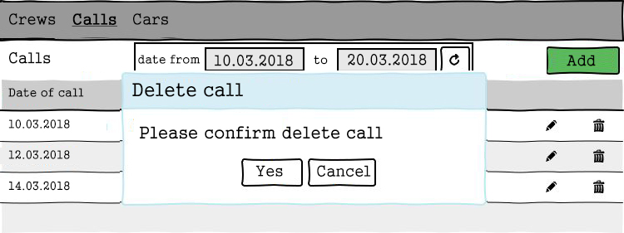

Рис. 2.4 Delete call dialog.

**3. Cars**

**3.1 Display list of cars**

This mode is intended for viewing and editing the cars list

***Main scenario:***

* User selects item “Cars”;
* Application displays list of cars.

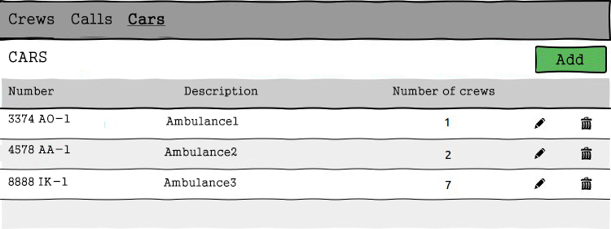

Pic. 3.1 View the cars list.

The list displays the following columns:

* Number – registration plate of the car;
* Description – car description;
* Number of crews – number of crews assigned to the car.

**3.2 Add car**

***Main scenario:***

* User clicks the “Add” button in the cars list view mode;
* Application displays form to enter car data;
* User enters car data and presses “Save” button;
* If any data is entered incorrectly, incorrect data messages are displayed;
* If entered data is valid, then record is adding to database;
* If error occurs, then error message is displaying;
* If new car record is successfully added, then list of cars with added records is displaying.

***Cancel operation scenario:***

* User clicks the “Add” button in the cars list view mode;
* Application displays form to enter car data;
* User enters car data and presses “Cancel” button;
* Data don’t save in data base, then list of cars records is displaying to user.
* If the user selects the menu item "Crews”, ”Calls” or "Cars", the data will not be saved to the database and the corresponding form with updated data will be opened.

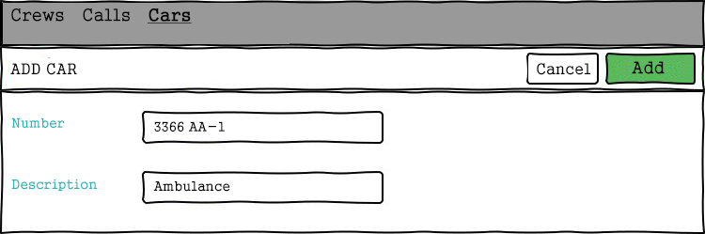

Pic. 3.2 Add car

When adding a call, the following details are entered:

* Number – registration plate of the car;
* Description – car description.

Restrictions:

* Number – requirements of the state standard the Republic of Belarus to the registration plate of the car;
* Description – optional field, up to 255 characters.

**3.3 Edit car**

***Main scenario:***

* User clicks the “Edit” button in the cars list view mode;
* Application displays form to enter car data;
* User enters car data and presses “Save” button;
* If any data is entered incorrectly, incorrect data messages are displayed;
* If entered data is valid, then edited data is added to database;
* If error occurs, then error message is displaying;
* If car record is successfully edited, then list of cars with added records is displaying.

***Cancel operation scenario:***

* User clicks the “Edit” button in the cars list view mode;
* Application displays form to enter car data;
* User enters car data and presses “Cancel” button;
* Data don’t save in data base, then list of cars records is displaying to user.

If the user selects the menu item "Crews”, ”Calls” or "Cars", the data will not be saved to the database and the corresponding form with updated data will be opened.

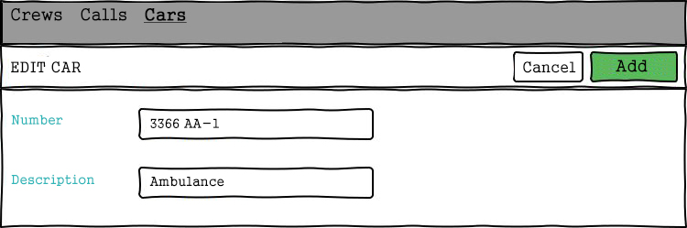

Pic. 3.3 Edit car.

**3.4 Removing the car**

***Main scenario:***

* The user, while in the list of cars mode, presses the "Delete" button in the selected car line;
* Application displays confirmation dialog “Please confirm delete car?”;
* The user confirms the removal of the car;
* Record is deleted from database;
* If error occurs, then error message displays;
* If car record is successfully deleted, then list of cars without deleted records is displaying.

***Cancel operation scenario:***

* User is in display mode of cars list and press “Delete” button;
* Application displays confirmation dialog “Please confirm delete car?”;
* User press “Cancel” button;
* List of cars without changes is displaying.

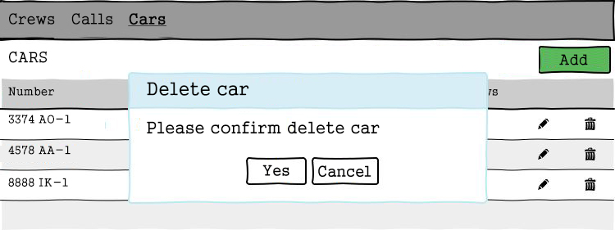

Pic. 3.4 Delete car dialog.